**Assignment 9 – Part 1  
Set 10.1 : 9, 27.b, 44 p668**

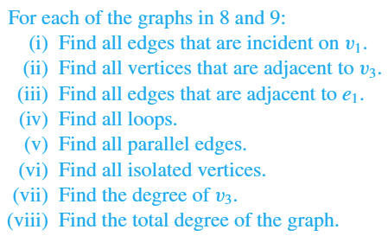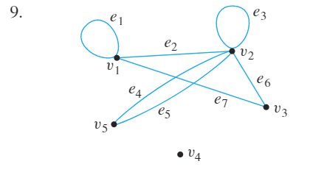

**9.i.) $e_{1}, e_{2, } and e_{7} are incident on v_{1}$**

**9.ii.) $v_{1} and v_{2} are adjacent to v_{3}$**

**9.iii.) $e_{2} and e_{7} are adjacent to e_{1}$**

**9.iv.) $Loops are e_{1} and e_{3}$**

**9.v.) $e_{4} and e_{5} are parallel$**

**9.vi.) $v_{4} is an isolated vertex$**

**9.vii.) $degree of v_{3}=2$**

**9.viii.) $total degree=14$**

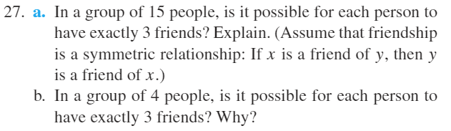

**27.b.) Yes, a graph representing each person by a vertex and connecting two vertices by an edge if the corresponding people were friends. Such a graph would have 4 vertices, each of degree 3, for a total degree of 12. The total degree is even, which is what we need to show.**

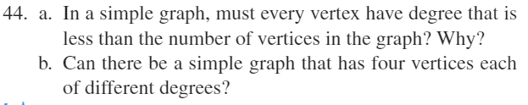

**44.a.) Yes, the maximum degree will always be n-1, where n is the number of vertices in the graph.**

**44.b.) No**